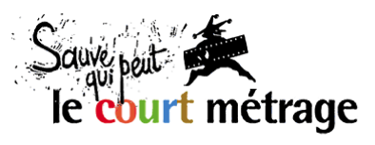 | presents | EURO CONNECTION X  6-7 February 2018 – Clermont-Ferrand

Euro Connection is the European Short Film Co-production Forum taking place each year at the Clermont-Ferrand Short Film Market. This business platform aims at fostering partnerships between European production companies for short film projects.

The next edition of Euro Connection will take place on Tuesday 6 and Wednesday 7 February 2018 during the Clermont-Ferrand Short Film Market. Euro Connection is organised by Sauve Qui Peut le Court Métrage (Clermont-Ferrand) in association with the Centre National du Cinéma et de l’Image Animée, with the support of the Creative Europe MEDIA sub-programme and the PROCIREP.

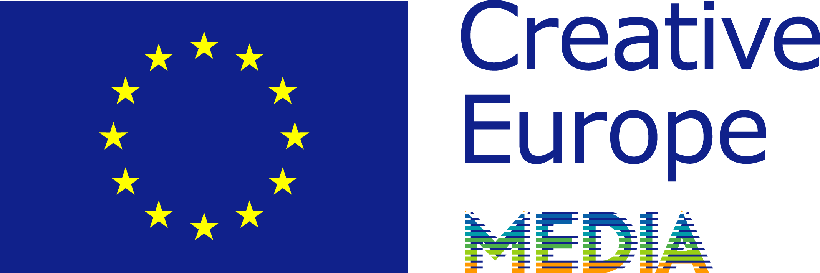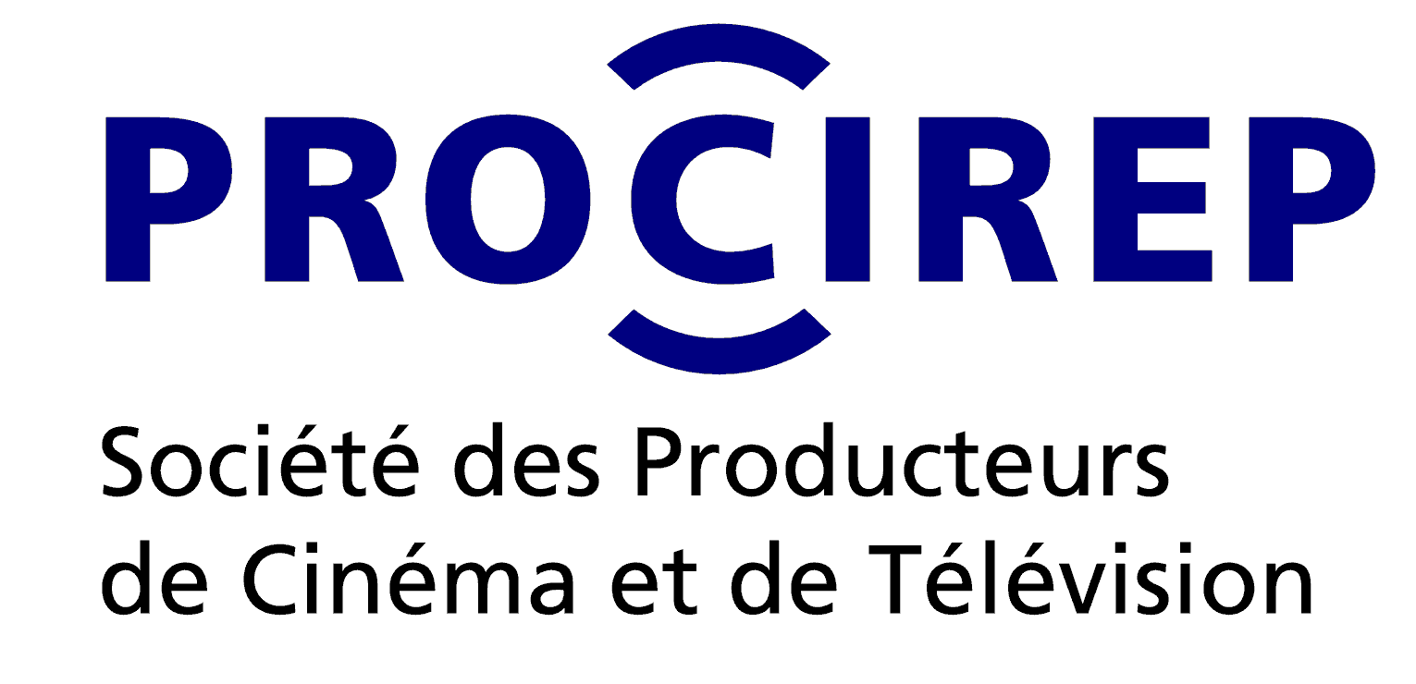

CALL FOR PROJECTS 2018

What is Euro Connection?
Each year 15 short film projects are selected across Europe to participate in Euro Connection, with the help of a network of national correspondents in each of the associated countries. The producers of the selected projects receive an invitation that includes a travel grant, hotel accommodation, meals and a free accreditation to the Short Film Market in Clermont-Ferrand.

The selected projects are highlighted in the Book of Projects and Producers, with details for each project and a profile of their authors and producers. Its publication (mid-January) is announced to European producers, broadcasters, fund representatives and financial backers registered to Clermont-Ferrand, who are invited to secure attendance to the pitching sessions during Euro Connection.

The event revolves around:
- Pitch training workshop (Monday 5 February 2018).
- Pitching sessions (Tuesday 6 February).
- Facilitated networking for producers and participants.
- One-on-one business meetings (Wednesday 7 February).

150 industry delegates take part in Euro Connection each year.
So far, 72 films were completed, including 34 European co-productions as a direct result from the first eight editions of Euro Connection.

How does it work?
Producers officially located in one of the associated countries must send their application by email to the national correspondent in their country no later than October 20, 2017 (entry form and contacts above).

In each country the national correspondent sets up an expert committee who will review the applications and nominate 1 finalist project. The expert committees will especially pay attention to the artistic value of the projects. Each national correspondent will inform the applicants of the results of the nomination of the finalist project. The producers of the finalist projects will be expected to send an English version of their application, including script, promptly after the nominations (for producers who apply to their correspondents with an application in another language than English).

A European jury will then meet and elect up to 15 selected projects from all the finalist projects. The jury will include 3 to 5 industry professionals from different nationalities. All finalist participants will be informed of the list of selected projects for Euro Connection by the end of November 2017.

For Baltic countries (Estonia, Latvia, Lithuania), the winning project of the Baltic Pitching Forum (Vilnius, October 6 & 7, 2017) will be selected for Euro Connection, as a result from the partnership between these two events. For Denmark, the Danish finalist project will be nominated with the results of Pitch Me baby (Odense, August 31, 2017), in partnership with the Odense Film Festival and the Creative Europe desk in Denmark.

Who can apply, and what are the eligibility criteria?
May apply producers whose company is officially located in one of the countries associated to the 2018 edition: Austria, Belgium (French-speaking), Bulgaria, Croatia, Cyprus, Czech Republic, Denmark, Finland, France, Germany, Greece, Hungary, Ireland, Italy, Luxembourg, Malta, Netherlands & Flanders, Poland, Portugal, Romania (to be confirmed), Slovenia, Spain, Sweden, United Kingdom.

Only projects respecting the following eligibility criteria will be considered:
- The project is a short film (animation, fiction, creative documentary).
- The duration does not exceed 40 minutes.
- The project must have partial funding granted by an external source (third party organisation).
- The producer is open to international co-production (project suitable or intended for co-production)
- Shooting or production shall start no earlier than May 2018.

Any producer applying with a project formally commits to attend Euro Connection in person in Clermont-Ferrand in case of selection.
Sending the application
Producers must send their application by email to the national correspondent in their respective country (see table below) no later than October 20, 2017. Applications shall be sent as 1 single pdf file containing the entry form below carefully filled out, with all other additional documents required. Incomplete applications or ineligible projects will not be considered. The correspondents are at the disposal of applicants for any query regarding application with a project.

Invitation for producers
The producer of each selected project will be invited to Euro Connection (limited to one person per production company) to pitch their project. Invitation covers:
- A 160 € travel grant
- 4 hotel nights and meals (Arrival Sunday 4 Feb. – Departure Thursday 8 Feb. 2018)
- Full accreditation to the Short Film Market in Clermont-Ferrand.

The authors/directors of the projects will be welcome (in shared hotel room with producer) and will also be granted a free Market accreditation.

The producers of the remaining finalist projects, outside the final selection, will also be invited to attend Euro Connection (4 hotel nights + meals + accreditation, for 1 person per project) for networking with attending industry delegates.

Contact
Euro Connection, Short Film Market Clermont-Ferrand – www.clermont-filmfest.com
Laurent Crouzeix: +33.(0)4 73 14 73 12
Julie Rousson: +33.(0)4 73 14 22 / euroconnection@clermont-filmfest.com
Entry form – Euro Connection 2018

Short film project
Original title: ……………………………………………………………………………………...……
English title: ………………………………………………………………………..............................
Directed by: …………………………………………………………………………………………...
Script by: …………………………………………………………………………………………….....
Production company: ………………………………………… Country:…………………........
Producer’s name: …………………………………………………………………………………….
Short synopsis / description (500 signs max.):

Key contact details
Producer’s e-mail:………………………………... Mobile phone: …………………………………..
Director’s e-mail:………………………………….. Mobile phone: ……………………………………
Production company’s address:........................................................................................................
Postcode: ………………… City: …………………………………………………………
Phone: ………………………………….. Website:……………………………………….......

Tech specs
Genre:  fiction  animation  creative documentary
Planned shooting format: ……………………………………………
Estimated running time: ………………….. minutes
Planned dates of shooting: ........................................................................

Budget and financing
Total estimated budget (in euros): ……………………………………… €
Secured funding (at time of application): ……..…..………............... € ( i.e. .… % of budget)
 I confirm that project has secured partial funding from an external source.
Amount of funding granted: ……..…..………............... €
Origin of funding:
❒ script development grant  broadcaster
❒ state production fund  prize/award/foundation money
❒ local/regional/city production fund  other (specify:…………………...................)
Funding granted by (name of organization):...............................
Confirmed on (date): ..................................

Director’s short bio (750 signs max.)

Production company profile (500 signs max.)

Producer’s short bio (750 signs max.)

Additional following documents are requested

- Complete script;
- The director's letter of intent (artistic note);
- CV and photo of director;
- Proof of funding granted by third party organisation (confirmation notice, letter, etc.);
- The producer’s letter of intent;
- CV and photo of producer;
- Filmography and logo of production company;
- Video link to previous film (or clips) by same director (if available).
These documents are intended for sole use of the expert committees and European jury. Information provided may be published publicly in case of selection.

 I commit to attend Euro Connection (Feb. 4-8, 2018) in Clermont-Ferrand if my project is selected.
 I understand that the information contained in this form will be published if my project is selected and might be edited for publication purposes in the Book of Projects.

Full name : | Signature :
Date :

Fill out your entry form carefully and send by email to your national correspondent (see table attached) in 1 single pdf file together with the additional documents required.
Associated countries & national correspondents for Euro Connection 2018

AUSTRIA
Vienna Independent Shorts Marija Milovanovic
marija.milovanovic@viennashorts.com

BELGIUM (Wallonia-Brussels Federation)
Wallonie Bruxelles Images Geneviève Kinet
genevieve.kinet@wbimages.be

BULGARIA
Creative Europe Desk Kamen Balkanski
info@mediadesk.bg

CROATIA
Creative Europe Desk Croatia – MEDIA office
Martina Petrovic
martina.petrovic@mediadesk.hr

CYPRUS
International Short Film Festival of Cyprus
Alexia Roider, Kimonas Mylonas
info@isffc.com.cy

CZECH REPUBLIC
Czech Film Center Marketa Santrochova
marketa@filmcenter.cz

DENMARK
Odense Film Festival (winner of Pitch me baby! will become finalist)

FINLAND
Tampere Short Film Festival Juhani Alanen
juhani.alanen@tff.fi

FRANCE
Sauve Qui Peut le Court Métrage
Laurent Crouzeix
l.crouzeix@clermont-filmfest.com

GERMANY
AG Kurzfilm e.V. German Short Film Association Franziska Kache
kache@ag-kurzfilm.de

GREECE
Greek Film Centre Stavroula Geronimaki
stavroula.geronimaki@gfc.gr

HUNGARY
Daazo Zsuzsanna Brasher
zsuzsanna.brasher@daazo.com

IRELAND
ITALY
Centro Nazionale del Cortometraggio
Jacopo Chessa, Eugènie Bottereau
promozione@centrodelcorto.it

LUXEMBOURG
Film Fund Luxembourg
Norbert Laporte Norbert.Laporte@filmfund.etat.lu
Carole Kremer carole.kremer@creative-europe.etat.lu

MALTA
The Film Grain Foudation Angélique Muller
+356 99555976 angelique@filmgrainfoundation.org

NETHERLANDS & Flemish Community
Go Short, Leuven ISFF Stella de Wijk
info@goshort.nl

POLAND
Krakow Film Foundation Barbara Orlicz
barbara.orlicz@kff.com.pl

PORTUGAL
Festival Curtas Vila do Conde
Miguel Dias mdias@curtas.pt
Festival IndieLisboa
Miguel Valverde miguel.valverde@indielisboa.com

ROMANIA
Romanian Film Promotion Alexandra Boghiu
+40 213 266 480 alexandra.boghiu@tiff.ro

SLOVENIA
Kraken Short Film Promotion Society
Bojana Bregar bojana@kraken.si

SPAIN
Madrid en corto Ismael Martín
ismael@madridencorto.es

SWEDEN
Swedish Film Institute Erika Wasserman erika.wasserman@filminstitutet.se

UNITED KINGDOM
British Council Alice Cabanas
Alice.Cabanas@britishcouncil.org

BALTIC COUNTRIES
Baltic Pitching Forum - (winner Best Pitch)

IndieCork Film Festival Una Feely
una@indiecork.com

Correspondents who’ll receive 10 applications or more in their country can nominate up to 2 finalist projects.
In-kind contributions or investment share from the original production company are not considered valid as acquired partial funding in the respect of this selection process. To be eligible, the partial funding secured must come from a third party organisation (i.e script development grant, production fund, state or local government support, investment from a broadcaster, prize money from a foundation or contest, etc.) and must correspond to development or production money. No minimum amount or percentage is required.

